This document contains a number of master forms in Word Format. The event title, organizing authority and an event logo can be inserted into the document header and footer once and it will appear on all printed forms. Be careful that expanding the header and footer does not affect the forms fitting onto one page.

Once headed, a different number of copies of each page can be printed to provide a set of paper masters. Please check the page breaks before printing. The forms are designed for A4.

Some forms will not be needed, as they will be contained in an online system used for the event. This is now common for hearing schedules and RRS 42 penalties. Not all forms will be needed for all events. For instance, some events do not need crew substitutions to be authorised, while others do not permit them at all.

Some forms may need to be saved as part of the event records. This will include Case Decisions. For these forms it is best to copy the master, including the header, to an separate document before the start of the event. Then use a copy of this master for each Case Decision.

The forms in this document are:
- Hearing Request Form and Other Requests for Action by the Protest Committee
- Protest Committee Decision
- Hearing Checklist
- Information for Observers
- Case Cover
- Notification from Protest Committee/Jury to Scorer
- Notice of Intent to Protest by a Committee
- Notice of hearing called against support persons
- Warnings to Competitors under RRS 62.4
- Notice to Competitors
- Kite Tangles
- Scoring Enquiry
- Penalty Acceptance or Retirement
- Protest Time Limits
- Notification of Intention not to Race
- Daily Times
- Race Committee Penalties
- Support Person and Support Boat Registration
- Equipment Replacement or Repair Request – general (plus separate Olympic Classes 6x)
- Haul Out Request
- Crew Substitution Request

And at the end three landscape (horizontal) forms:
- Protests and other Hearings Schedule and Decisions
- RRS 42 Worksheet
- RRS 42 Penalties

HEARING REQUEST FORM and OTHER REQUESTS FOR ACTION BY THE PROTEST COMMITTEE

Received  Date: Time: By: |  |  |  |  | Protest  Time Limit: |  |  | Case  Number:
1. Date of Race: |  |  |  | Series: |  |  | Race Number:
2. TYPE of HEARING ☐ Request to have a hearing full jury (RRS N1.4(b))
☐ Protest – (an allegation that one or more boats broke a rule)  ☐ Request for Redress  ☐ Request to Reopen a hearing (RRS 63.7(b)) |  |  |  |  | ☐ Report for DP Penalty (RRS 64)  ☐ Report concerning a Support Person (RRS 62)  ☐ Report of Misconduct (RRS 69)
3. MY DETAILS – The INITIATOR – the protestor, the person making the allegation, request or report
Class/Fleet: S |  | Sail No/Boat Name: |  |  | OR | Committee:
Represented By: | Name: |  |  |  |  |  | Telephone:
Represented By: |  |  |  |  |  |  | e-mail:
4. The RESPONDENT – protestee, committee for redress, support person, person reported for misconduct.
Class/Fleet or Committee |  |  | Sail No/Boat Name/Person |  |  |  | Telephone (if known)
5. INFORMING the PROTESTEE – If you are protesting, how did you inform the boat of your intention to protest?
By hailing: ☐ No ☐ Yes
Displaying Red Flag: ☐ Not required ☐ No ☐ Yes
Informed some other way: ☐ No ☐ Yes
6. The INCIDENT  Brief Description. |  |  |  |  | Diagram (if relevant): Include wind and current.
Rules alleged to be broken: |  |  |  |  | Names of witnesses:
Request to Withdraw: |  |  |  |  | Request Approved:
Continue on the back of this form or other paper if necessary.

PROTEST COMMITTEE DECISION Case No: With Case(s): Race:

PARTIES
Boat or Committee or Person | Event | Represented By/Not Present

WITNESSES
Name | Boat – Committee - Role
Valid – Yes/No (if ‘No’ use Facts Found to document this decision)
Case Summary: (type of Hearing and just brief introduction to help the reader)

Procedural Matters, (Conflicts of Interest,, parties not present, extending time limits)

Facts found:

Conclusion & Rules:

Decision:

Protest Committee: International Jury: Yes/No
Name MNA, IJ (Chair), Name MNA, IJ, Name MNA, IJ, Name MNA, IJ, Name MNA, IJ.

Signed: Date, time:

HEARING CHECKLIST Case Number:_______________

Note: 'N/A' means Not Applicable; 'N/C' means Not Completed or Not Considered by the protest committee.
See instructions for completing the checklist on page 2
(1) BEFORE THE HEARING (parties not present)  1.1 Protest hearing scheduled and posted (63.2)?   □ Yes □ No □ N/C  1.2 Hearing under App B or Add Q?   □ App B □ Add Q □ N/A  1.3 No interested party on jury (63.4)?   □ None □ Judge(s) recused _________________  1.4 International Jury properly constituted (App N)?   □ Yes □ No □ N/C  1.5 Contents (61.2)  (a) Protestor and protestee identified?    □ Yes □ No □ N/A □ N/C  (b) Incident identified    □ Yes □ No □ N/A □ N/C  (c) Reason for requesting redress identified    □ Yes □ No □ N/A □ N/C  1.6 Parties available   □ Yes □ No □ Postponed: ________________  1.7 Jury witnesses? Judge saw the incident?   □ Yes □ Identified □ No □ N/C  1.8 Is TV coverage available?   □ Yes □ Obtained □ Unknown □ No □ N/C  (2) HEARING PRELIMINARIES (parties present)  2.1 Observers and Instructions   □ Verbal □ Handouts □ N/A  2.2 Understand English / Help Needed?   □ Done □ N/A □ N/C  2.3 Correct hearing and participants   □ Done □ N/A □ N/C  2.4 Policy on recordings   □ Done □ N/A □ N/C  2.5 Record names (from accreditation)   □ Done □ N/A □ N/C  2.6 Party(s) present?   □ Yes □ No □ Proceed under 63.3(b)  2.7 Boat’s rep on board for Part 2, 3 or 4 (63.3)   □ Yes □ No □ N/A □ N/C  2.8 Introduce Jury?   □ Done □ N/C  2.9 Objections on grounds of interest (63.4)?   □ None □ Yes □ Valid □ Invalid □ N/C  2.10 Copy of protest form - time to prepare (63.2)?   □ Done □ Extend: _______________ □ N/C  2.11 Parties understand procedure?   □ Yes □ No □ Explained □ N/C | 2.12 Any penalties taken?   □ Yes □ No □ N/C  2.13 Request to withdraw protest (63.1)?   □ No □ Yes □ Approved □ Denied  2.14 Will parties be calling any witnesses?   □ Yes □ No □ N/C  (3) VALIDITY  3.1 Contents – parties, incident (61.2, 62.2)   □ OK □ Corrected □ N/C  3.2 Protest delivered within time limit (61.3, 62.2)?   □ Yes □ No □ Extended: _______________  3.3 Hail (61.1)?   □ Yes □ No □ N/A _____________________  3.4 Flag displayed (61.1)?   □ Yes □ No □ N/A _____________________  3.5 If no hail, Protestee properly informed (61.1)?   □ Yes □ No □ N/A _____________________  3.6 For Part 2, protestor involved in or saw incident (60.1(a))?   □ Yes □ No □ N/A □ N/C  3.7 For boards – informed race committee (B5)   □ Yes □ No □ N/A □ N/C  (4) EVIDENCE  4.1 □ Each party gives evidence (M3.2)  4.2 □ Parties question each other (M3,2) □ N/A  4.3 □ Witnesses of parties (63.6 & M3.2) □ N/A  4.4 □ Witnesses questioned (M3.2) □ N/A  4.5 □ Jury evidence (63.6) □ N/A  4.6 □ Jury questions (M3.2)  4.7 □ Summaries (last opportunity) (M3.2) □ N/C  (5) DECISION  5.1 Parties present (65.1)   □ Yes □ No □ Partial ___________________  5.2 Decision date and time on form and jacket    □ Yes □ No  5.3 Request for copy of decision?   □ Verbal □ Written □ No □ Granted □ Denied  (6) SUMMARY  6.1 Any concerns or unusual procedures?   □ No □ Yes Explain (cont. reverse side): _______  ____________________________________________

Recorded by: Recorder's Signature:
Panel Chairman: Date: Time:
Instructions for Hearing Checklist

1 Before the Hearing (no parties present)

1.1 Verify protest schedule was posted with enough time between posting and the hearing. See RRS 63.2
1.2 Hearing conducted under RRS App B or Add Q. Otherwise N/A.
1.3 Usually 'None'. If necessary, replace a panel member who is an interested party.
1.4 Chair checks the constitution of the panel under RRS App N1 and applicable ISAF Regulations.
1.5 Contents
(a) Protestor and protestee(s) properly identified. Can be corrected under 3.1.
(b) Description of incident is acceptable. Cannot be corrected later.
(c) Reasons for redress meet RRS 62.2. Can be corrected under 3.1.
1.6 Are the parties available? Decide whether to proceed or postpone the hearing time.
1.7 Did any panel member witness the incident? Chair instructs panel members. RRS 63.3(a) applies.
1.8 Could there be media (TV, tracking) evidence available as useful evidence? Can it be obtained?

2 Hearing Preliminaries (parties present)

2.1 Observers present? If so, provide the rules and instructions for the observer(s).
2.2 Do the parties understand / speak English. Is an interpreter needed? Provide instructions to the interpreter.
2.3 “This is an incident between <who> at <where> <when>. Is this correct?”
2.4 Explain the policy on recording. Usually no video or audio recording. Cell phones off.
2.5 Obtain the full names of the parties. Obtain full names of witnesses when they appear.
2.6 Are all parties present? If not, recheck notification procedures. Postpone or continue under RRS 63.3(b).
2.7 For incidents involving RRS Part 2, 3 or 4, verify that the representatives were on board. RRS 63.3
2.8 Introduce panel members.
2.9 Are there any objections to member(s) of the jury on grounds of being an interested party?
2.10 Does protestee have a copy of the protest? Needs time to prepare? Ready to proceed? RRS 63.2
2.11 Parties understand the protest procedure? If not, chair explains process.
2.12 Have any penalties been taken? If yes, go to 2.13.
2.13 Yes if the protestor wants to withdraw the protest and the panel approves. Can happen out of sequence.
2.14 Ask if any party will be calling a witness(es).

3 Validity

3.1 Review contents and any issues from 1.5 with the parties.
3.2 Yes, if filed before the PTL. If extended, provide reason. Use 6.1 if necessary to describe reasons.
3.3 If N/A, provide reason or rule, e.g., “RC protest”, 61.1(a)(1), 61.1(a)(4), etc.
3.4 If N/A, provide reason or rule, e.g., “< 6m”, 61.1(a)(2), 61.1(a)(4), etc.
3.5 Applies mainly to RC and PC protests.
3.6 Protestor's representative was involved in or saw the incident. RRS 60.1(a).
3.7 For boards only, the protestor informed the RC in compliance with RRS B5.

4 Evidence

Follows RRS App M and ISAF Judges Manual.

5 Decision

5.1 Yes, all present. No, none present. Partial, at least one present. If N/A, explain.
5.2 Form is dated and signed.
5.3 No, unless a verbal or written request for a copy is received by the panel before closing the case. Grant all requests with the possible exception of hearing decisions involving misconduct.

6 Summary

6.1 Provide notes on any unusual procedures or other relevant items. _______________________________________________________________________________________

_______________________________________________________________________________________
Information for Observers Attending Hearings

Each observer at a hearing is asked to read, sign this document and return it to the Panel Chairman.
This document will be retained with the case papers.

- Observers
  - Observers’ attendance is at all times at the discretion of the Jury Chairman or Panel Chairman and any observer shall comply with the Panel Chairman’s directions at all times.
  - A party may object to an observer attending the hearing and the Jury Chairman or Panel Chairman shall then determine if it is appropriate for the observer to attend or be excluded from the hearing.
  - The Panel Chairman may revoke permission for an observer to attend the hearing at any time.
- Observers’ conduct
  - Electronic equipment (including telephones, cameras or any recording devices) shall be switched off at all times while in the Hearing Room.
  - No communication is permitted between parties, witnesses and/or observers in the Hearing Room, unless permitted by the Panel Chairman.
  - Attention is drawn to RRS 63.4(e), which states that witnesses, except for members of the International Jury (protest committee), shall be excluded from a hearing except when giving evidence. If an observer is aware that he is, or may be, a witness, he must declare this to the Panel Chairman at the start of the hearing.

Chair, International Jury

Date: | Case Nr:

Name of observer | Role | Signature

CASE COVER

Case Number | Date: | Race: | Related Cases

Type of Case
PROTEST | REDRESS | REOPEN | SUPPORT | MISCONDUCT

Time Filed: |  |  | Time Limit:
INITIATOR: |  |  | RESPONDENT:
Event: |  |  | Event:

Case Status |  |  | Case Status (secretariat)
Notification to RC | --- |  | Scoring Instructions
Created | --- |  | Results checked
Scheduled | --- |  | Publication approved
Decided | --- |  | Decision Published

Scheduled Date/Time: |  | Decision Date/Time: |  |  | Published Date/Time:
Short Decision:

Scoring Instruction:

Chair | Scribe |  | Panel | Panel |  | Panel
Quality Check By: |  | Quality Check Date/Time:

NOTIFICATION FROM PROTEST COMMITTEE/JURY TO SCORER

The protest committee/Jury have made decisions to change scores as listed below.

Date:

Class – Fleet  Sail Number | Race | Case | Scoring Instruction | Entered  By/Time

Submitted by: Name Signature: Time:

Notice Of Intent to Protest a Boat by a Committee
(in accordance with RRS 60.2(a)(2)

Date:

Race | Committee Protesting | Boat Protested  Class/Fleet  Sail No/Name | Rule(s) | Incident Location | Time  Posted

RC = Race Committee
PC = Protest Committee
TC = Technical Committee

Hearing times will be posted in the hearing schedule as soon as possible. A copy of the actual protest will be available from the jury office before the hearing.

Posted by:

NOTICE OF HEARING UNDER RRS 62.1 – SUPPORT PERSONS
and their SUPPORTED BOATS

Date:

Support Person | Competitors | Class/Fleet | Rule | Incident Location/Time | Race

Hearing times will be posted in the hearing schedule as soon as possible. A copy of the actual allegation will be available from the jury office before the hearing.

Competitors listed above are invited to attend the hearing. They should be aware that if the allegation is upheld there is a possibility that competitors may be penalised in accordance with RRS 64.4(b).

The protest committee will also determine if a warning is appropriate under RRS 62.3(a) at the hearing.

Posted By:

Date and Time:

NOTICE of WARNINGS to COMPETITORS UNDER RRS 62.4

RRS 62.4 states: The protest committee may also penalize a competitor for the breach of a rule by a support person by changing the boat’s score in a single race, up to and including DSQ, when the protest committee decides that…. (2) the support person commits a further breach after the competitor has been warned by the protest committee that a penalty may be imposed.

The following warnings have been issued to competitors under this rule:

Case Number | Support Person | Rule Broken | Competitors Warned

Posted By

Date: Time:

NOTICE to COMPETITORS

Number: | Date: | Time:
Title:

Subject:

From (Committee):

Signature:

Name:

KITE TANGLES

RRS F5 60.5(e): ‘if a kiteboard has broken a rule and, as a result, caused a tangle for the second or subsequent time during the event, her penalty shall be a disqualification that is not excludable.’
Note: This rule may not apply to a medal race series.

Record of Kite Tangles

Competitor | Event | Case Number | Race Number | Tangle Number this competitor

SCORING ENQUIRY

This form is to be used for scoring enquiries and will be sent to the Race Committee in the first instance. If you are not satisfied by the response of the Race Committee you remain entitled to request redress in accordance with rule 61. If any request is outside the protest time limit the protest committee may extend the time limit provided you have acted promptly at all times and followed up this enquiry in a timely manner.

REQUEST

Event: __________________________________________ Race No: __________

Sail No: _______________________ Boat Name: ______________________________

Reason for Enquiry:

Boat believed to finish one place in front, if relevant:

Boat believed to finish one place behind, if relevant:

Name: _____________________________ Signature: _________________________
Date: _____________________________ Time: _____________________________

RECEIPT of REQUEST
Date: Time: By: Sequence No:

RESPONSE by RACE COMMITTEE

Date: _______________________ Time: _____________________________

Name: _________________________________ Signature: __________________________

Penalty Acceptance (incl. discretionary penalty) or Retirement Form
(Please use a separate form for each incident)
Boat Name: | Person in Charge:

Event: | Sail Number: | Bow Number:

Incident Details – please write on the other side if you need more space
Race No: | Date: |  | Approx Time:
Incident Location:

Brief description:

Other boat(s) involved: |  | Describe any Damage:
Describe any advantage gained by boat accepting a penalty:

Penalty  □ 2 Turns Penalty  □ 1 Turn Penalty  □ Retired – Did not Finish (DNF)  □ Retired – Retired After Finishing (RET)  □ Other – describe  □ Breach subject to Discretionary Penalty | Rule:  □ No rule broken  □ Part 2 (Boat v Boat)  □ 31 (Mark Touch)  □ 28 (Sailing the Course)  □ Other - describe

Name (Print): _________________________ Signature: ___________________________

Date: _______________________________ Time: ______________________________

For official use only
Received By: | Name: | Date/Time

Discretionay Penalty to be Applied
Approved by Protest Committee: | Name: | Date/Time
Entered by Scoring: | Name: | Date/Time

Case No:

PROTEST TIME LIMITS

Event/Class/Fleet | Protest Time  Limit

The protest time limit is calculated according to the sailing instructions, or 2 hours after the last boat to finish [RRS 60.3(b)]

NOTIFICATION OF INTENTION NOT TO RACE

To be completed by a boat that does not intend to race for any reason. A boat that completes this form accepts that they will be scored Did Not Compete (DNC) for the race(s) in question. This avoids a boat being given a penalty for failing to check-out, check-in, collect trackers etc.

Class/Fleet | Sail Number | Race(s) | Name | Signature

DAILY TIMES

The protest time limit is calculated according the sailing instructions, or 2 hours after the last boat to finish [RRS 60.3(b)]

The scoring enquiries time, is the time the race officers will be ashore and available in the race office to discuss scoring enquiries.

Equipment Inspection is the latest time that a notice will be posted to give instructions to boats regarding equipment inspection

Date:

Event/Class/Fleet | Protest Time  Limit | Scoring  Enquiries | Equipment Inspection

RACE COMMITTEE PENALTIES

The Race Committee have applied the following penalties:

Date: Time:

Class/Fleet | Sail Number | Race No | Rule | Penalty

SP = standard penalty applied according to the Sailing Instructions and the Standard Penalty list.
UFD = a boat that has broken RRS 30.3
BFD = a boat that has broken RRS 30.4

Posted By

SUPPORT PERSON and SUPPORT BOAT REGISTRATION

MY DETAILS

First Name: | Last Name:
Sailor ID: | Role:
Email: | Event Telephone:

MY BOAT (if applicable)

Make: | Colour:
LOA: | Engine:
ID Number if Any: | Maximum No of Persons Permitted on Board:

COMPETITORS I SUPPORT

Competitor’s Name | Sail No | Competitor’s Name | Sail No

ACCEPTANCE of the RULES

I agree that I am governed by the Racing Rules of Sailing. I have read and understood the rules of the event as stated in the Notice of Race.

If I drive or operate a support boat, I confirm that I hold a valid licence or permit to do so as required by the local regulations.

I confirm that any support boat I will operate, or be responsible for, complies with local legislation.

I am aware that I may be required to ensure that all persons on board a support boat wear personal floatation devices at all times while afloat and that the operator/driver of the boat may be required to use an operational engine kill cord at all times while the engine is running.

Signature:

Date: Time:

EQUIPMENT REPLACEMENT OR REPAIR REQUEST - GENERAL

REQUEST by Boat/Class/Sail No:

Reason | ⃝ damaged | ⃝ lost |  | Date/Race:
Request | ⃝ replace | ⃝ repair |  | Date/Race:
Description:

If replacement / repair was made prior to written approval, state the reason.

Name/Position: |  |  | Date/Time:
Signature:

RECEIPT of REQUEST
Date/Time: By: Sequence No:

RESPONSE by ITO from TECHNICAL COMMITTEE
 | ⃝ Request approved | ⃝ for repair | ⃝ and needs measuring
 |  | ⃝ for replacement | ⃝ and needs measuring
 | ⃝ Request denied
Damaged equipment impounded? |  | ⃝ YES | ⃝ NO

In the case of damaged equipment, I have inspected the damaged equipment and I am satisfied such damage was accidental.
Comments or Limitations:

Name/Position: |  | Signature: | Date/Time:

filled by ITO from TECHNICAL COMMITTEE if request is marked as
“approved” AND “needs measuring”
Equipment is measured and approved |  | ⃝ YES | ⃝ NO
Name/Position: |  | Signature: | Date/Time:

EQUIPMENT REPLACEMENT OR REPAIR REQUEST – One Person Dinghy
REQUEST by Boat/Class/Sail No:

Reason | ⃝ damaged | ⃝ lost |  | Date/Race:
Request | ⃝ replace | ⃝ repair
Description: |  |  |  |  | Mark on the drawing
If replacement / repair was made prior to written approval, state the reason.
 |  |  |  |  | ⃝ port | ⃝ starboard
Name/Position: |  |  | Date/Time:
Signature:

RECEIPT of REQUEST
Date/Time: By: Sequence No:

RESPONSE by ITO from TECHNICAL COMMITTEE
 | ⃝ Request approved | ⃝ for repair | ⃝ and needs measuring
 |  | ⃝ for replacement | ⃝ and needs measuring
 | ⃝ Request denied
Damaged equipment impounded? |  | ⃝ YES | ⃝ NO

In the case of damaged equipment, I have inspected the damaged equipment and I am satisfied such damage was accidental.
Comments or Limitations:

Name/Position: |  | Signature: | Date/Time:

filled by ITO from TECHNICAL COMMITTEE if request is marked as
“approved” AND “needs measuring”
Equipment is measured and approved |  | ⃝ YES | ⃝ NO
Name/Position: |  | Signature: | Date/Time:

EQUIPMENT REPLACEMENT OR REPAIR REQUEST – Mixed Dinghy

REQUEST by Boat/Class/Sail No:

Reason | ⃝ damaged | ⃝ lost |  | Date/Race:
Request | ⃝ replace | ⃝ repair
Description: |  |  |  |  | Mark on the drawing
 |  |  |  |  | 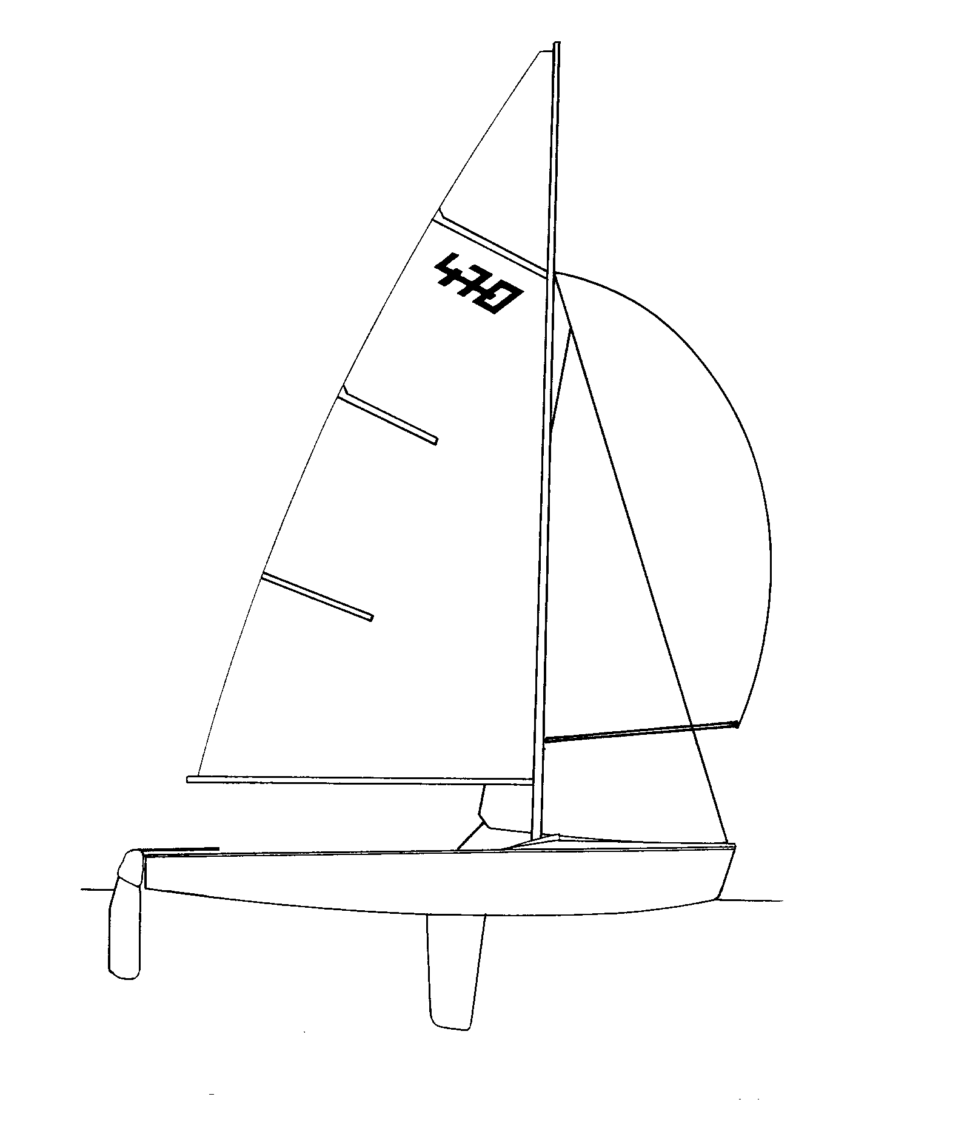
If replacement / repair was made prior to written approval, state the reason.
 |  |  |  |  | ⃝ port | ⃝ starboard
Name/Position: |  |  | Date/Time:
Signature:

RECEIPT of REQUEST
Date/Time: By: Sequence No:

RESPONSE by ITO from TECHNICAL COMMITTEE
 | ⃝ Request approved | ⃝ for repair | ⃝ and needs measuring
 |  | ⃝ for replacement | ⃝ and needs measuring
 | ⃝ Request denied
Damaged equipment impounded? |  | ⃝ YES | ⃝ NO

In the case of damaged equipment, I have inspected the damaged equipment and I am satisfied such damage was accidental.
Comments or Limitations:

Name/Position: |  | Signature: | Date/Time:

filled by ITO from TECHNICAL COMMITTEE if request is marked as
“approved” AND “needs measuring”
Equipment is measured and approved |  | ⃝ YES | ⃝ NO
Name/Position: |  | Signature: | Date/Time:

EQUIPMENT REPLACEMENT OR REPAIR REQUEST – Skiff

REQUEST by Boat/Class/Sail No:

Reason | ⃝ damaged | ⃝ lost |  | Date/Race:
Request | ⃝ replace | ⃝ repair
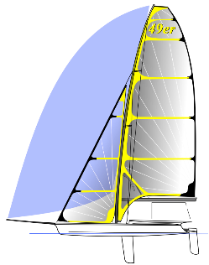  Description: |  |  |  |  | Mark on the drawing
 |  |  |  |  | 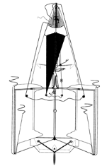
If replacement / repair was made prior to written approval, state the reason.
 |  |  |  |  | ⃝ port | ⃝ starboard
Name/Position: |  |  | Date/Time:
Signature:

RECEIPT of REQUEST
Date/Time: By: Sequence No:

RESPONSE by ITO from TECHNICAL COMMITTEE
 | ⃝ Request approved | ⃝ for repair | ⃝ and needs measuring
 |  | ⃝ for replacement | ⃝ and needs measuring
 | ⃝ Request denied
Damaged equipment impounded? |  | ⃝ YES | ⃝ NO

In the case of damaged equipment, I have inspected the damaged equipment and I am satisfied such damage was accidental.
Comments or Limitations:

Name/Position: |  | Signature: | Date/Time:

filled by ITO from TECHNICAL COMMITTEE if request is marked as
“approved” AND “needs measuring”
Equipment is measured and approved |  | ⃝ YES | ⃝ NO
Name/Position: |  | Signature: | Date/Time:

EQUIPMENT REPLACEMENT OR REPAIR REQUEST – Mixed Multihull

REQUEST by Boat/Class/Sail No:

Reason | ⃝ damaged | ⃝ lost |  | Date/Race:
Request | ⃝ replace | ⃝ repair
Description: |  |  |  |  | Mark on the drawing
 |  |  |  |  | 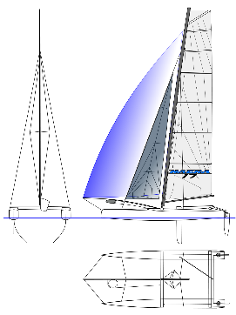
If replacement / repair was made prior to written approval, state the reason.
 |  |  |  |  | ⃝ port | ⃝ starboard
Name/Position: |  |  | Date/Time:
Signature:

RECEIPT of REQUEST
Date/Time: By: Sequence No:

RESPONSE by ITO from TECHNICAL COMMITTEE
 | ⃝ Request approved | ⃝ for repair | ⃝ and needs measuring
 |  | ⃝ for replacement | ⃝ and needs measuring
 | ⃝ Request denied
Damaged equipment impounded? |  | ⃝ YES | ⃝ NO

In the case of damaged equipment, I have inspected the damaged equipment and I am satisfied such damage was accidental.
Comments or Limitations:

Name/Position: |  | Signature: | Date/Time:

filled by ITO from TECHNICAL COMMITTEE if request is marked as
“approved” AND “needs measuring”
Equipment is measured and approved |  | ⃝ YES | ⃝ NO
Name/Position: |  | Signature: | Date/Time:

EQUIPMENT REPLACEMENT OR REPAIR REQUEST - Windsurfing

REQUEST by Boat/Class/Sail No:

Reason | ⃝ damaged | ⃝ lost |  | Date/Race:
Request | ⃝ replace | ⃝ repair
Description: |  |  |  |  | Mark on the drawing
If replacement / repair was made prior to written approval, state the reason.
 |  |  |  |  | ⃝ port | ⃝ starboard
Name/Position: |  |  | Date/Time:
Signature:

RECEIPT of REQUEST
Date/Time: By: Sequence No:

RESPONSE by ITO from TECHNICAL COMMITTEE
 | ⃝ Request approved | ⃝ for repair | ⃝ and needs measuring
 |  | ⃝ for replacement | ⃝ and needs measuring
 | ⃝ Request denied
Damaged equipment impounded? |  | ⃝ YES | ⃝ NO

In the case of damaged equipment, I have inspected the damaged equipment and I am satisfied such damage was accidental.
Comments or Limitations:

Name/Position: |  | Signature: | Date/Time:

filled by ITO from TECHNICAL COMMITTEE if request is marked as
“approved” AND “needs measuring”
Equipment is measured and approved |  | ⃝ YES | ⃝ NO
Name/Position: |  | Signature: | Date/Time:

EQUIPMENT REPLACEMENT OR REPAIR REQUEST – Kite
REQUEST by Boat/Class/Sail No:

Reason | ⃝ damaged | ⃝ lost |  | Date/Race:
Request | ⃝ replace | ⃝ repair
Description: |  |  |  |  | Mark on the drawing
If replacement / repair was made prior to written approval, state the reason.
 |  |  |  |  | ⃝ port | ⃝ starboard
Name/Position: |  |  | Date/Time:
Signature:

RECEIPT of REQUEST
Date/Time: By: Sequence No:

RESPONSE by ITO from TECHNICAL COMMITTEE
 | ⃝ Request approved | ⃝ for repair | ⃝ and needs measuring
 |  | ⃝ for replacement | ⃝ and needs measuring
 | ⃝ Request denied
Damaged equipment impounded? |  | ⃝ YES | ⃝ NO

In the case of damaged equipment, I have inspected the damaged equipment and I am satisfied such damage was accidental.
Comments or Limitations:

Name/Position: |  | Signature: | Date/Time:

filled by ITO from TECHNICAL COMMITTEE if request is marked as
“approved” AND “needs measuring”
Equipment is measured and approved |  | ⃝ YES | ⃝ NO
Name/Position: |  | Signature: | Date/Time:

HAUL OUT REQUEST

REQUEST by Boat/Class/Sail No:

Reason for haul out request & any relevant information:

If boat hauled out prior to approval, state the reason.

Name/Position: | Date/Time:
Signature:

RECEIPT of REQUEST
Date/Time: By: Sequence No:

COMMENTS by TECHNICAL COMMITTEE or OTHER (specify)

Name/Position: Sign: Date/Time:

RESPONSE by TECHNICAL COMMITTEE (or RACE COMMITTEE IF NO TECHNICAL COMMITTEE)

Approved/Denied

Comments or Limitations:

Name: Sign: Date/Time:

CREW SUBSTITUTION REQUEST

REQUEST by Boat/Class/Sail No:

Crew to be Substituted: Nationality: |  | Date/Race for Substitution to become effective:
Substitute Crew: Nationality: |  | Date/Race for Substitution to become effective:
Reason for substitution & any relevant information:

If substitution was made prior to approval, state the reason.

Name/Position: | Date/Time:
Signature:

RECEIPT of REQUEST
Date/Time: By: Sequence No:

COMMENTS by ___________________________________Position:

Name/Position: Sign: Date/Time:

RESPONSE by RACE COMMITTEE or OTHER AUTHORISED PERSON

Approved/Denied

Comments or Limitations:

Name: Sign: Date/Time:

Position:

Protest and Other Hearings Schedule and Decisions
CASE SUMMARY SHEET |  | DATE/TIME of POSTING |  |  |  |  | FINAL FOR THE DAY: YES / NO
Hearing Types: Protest / Request for Redress / Request to Re-open / Support Person / Misconduct

Case | Initiatior | Respondant | Hearing Type | Witnesses | Race | Rules Quoted | Hearing Date/Time | Decision | Rules Applied

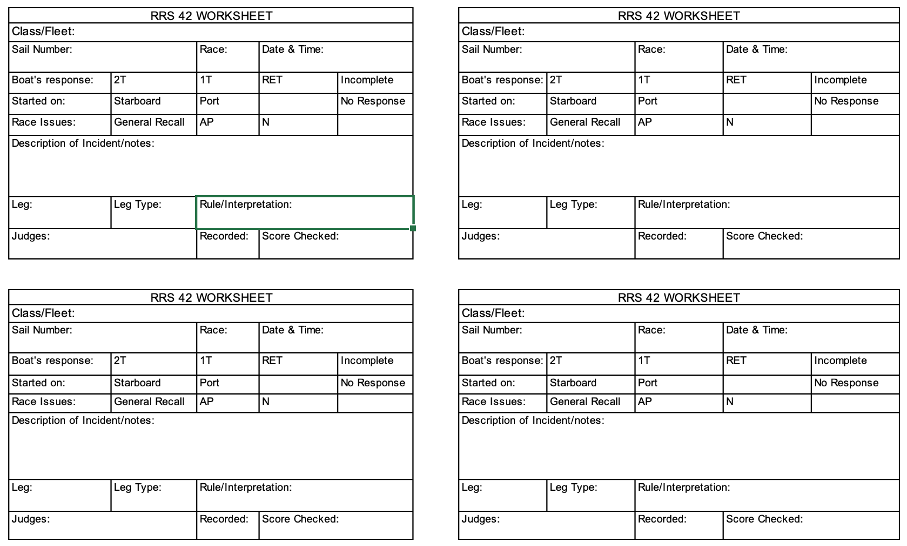

EVENT |  |  |  |  | CLASS:
Rule 42 Penalties |  |  | up to | Date:
 | First Penalty |  |  | Second Penalty |  |  | Third Penalty
Sail No | Race | Rule/ Interpretation | Penalty | Race | Rule/ Interpretation | Penalty | Race | Rule/ Interpretation | Penalty
Time: |  | Notice Posted by: |  |  |  | Signature:
Date:

